42.27: a) 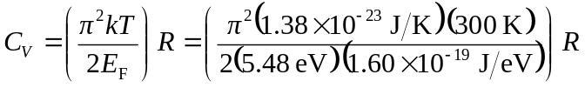
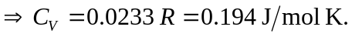
b) 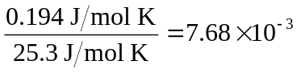.
c) Mostly ions (see Section 18.4).

